JECRC
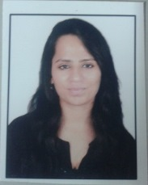Affix and Attest
passport
size photograph
JAIPUR

INDIVIDUAL FACULTY DATA SHEET
Name of the faculty member | : | YOGITA
Present Designation | : | Assistant professor
Email Id : yogita.ece@jecrc.ac.in
Contact Details : 828810282

I. Particulars of Educational Qualification: (only completed)

Category | Name of the Degree | Specialization | Year of Passing | Name of the College | Name of the University
UG | B.TECH | ECE | 2013 | B.M college of tech. & Mgmt. | M.D university, Rohtak
PG | M.TECH | VLSI DESIGN | 2016 | Banasthali vidyapith | Banasthali university
Ph.D.

II. Academic Experience : 9 month

III. Industrial Experience :nil

IV. Title of Ph.D. Thesis : nil

V. Awards/Achievements : GATE qualified, won best paper award.

VI. Research/Specialization : Nano Electronics

VII. Course Taught : DE, DLD and ICTECH

VIII. Refereed International Journal Publication : 1

IX. International Conference Proceeding : 1

X. Books Written : nil

XI. M.Tech Thesis Guide : Dr. Anurag srivastava

XII. PHD Thesis Guide : no

XIII. Professional Body Membership : no

